Signing Up for your TCI Teacher Subscription (KPBSD)

Your online Teacher Subscription contains everything you need to plan, teach, and assess each chapter’s lesson. If you hit any snags, call customer support at 1-800-497-6138.

Step 1: Copy and paste the following link into your browser. (Use Firefox or Google Chrome.) http://subscriptions.teachtci.com/teacher/3wv6r5v
Fill out the form. Use your district email, create your own password, check the “I agree” box, and then click the purple button.
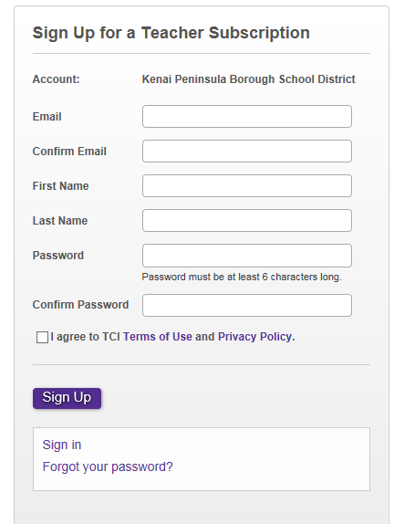

Step 2: You are now in your Teacher Subscription. Click “Add Program” and choose your grade level.

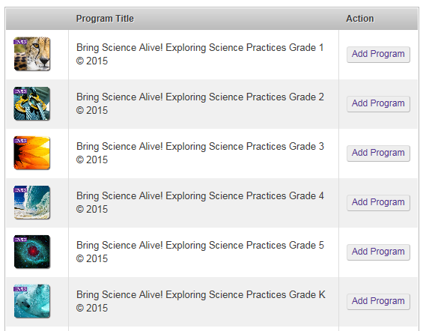
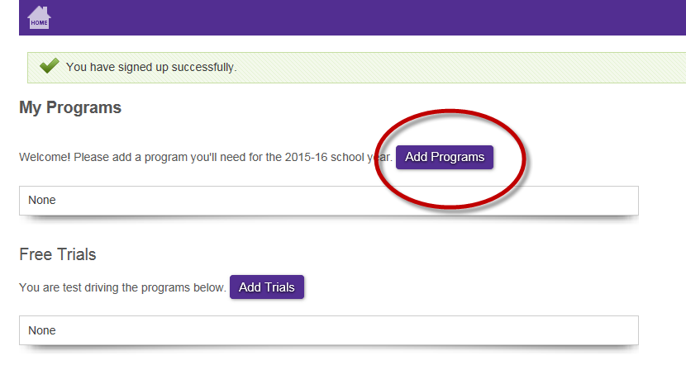
Step 3: Click on a purple lesson title, or click the “Teach” icon to the right of the title. This opens your visual lesson guide (TCI calls this a “Presentation”)—your one-stop shop for planning and teaching.

Click through the slides to plan your lesson before class, and then use these same slides with students when doing the activity during class.

To print or project the Interactive Student Notebook and any other handouts, click “Materials” in the top row.
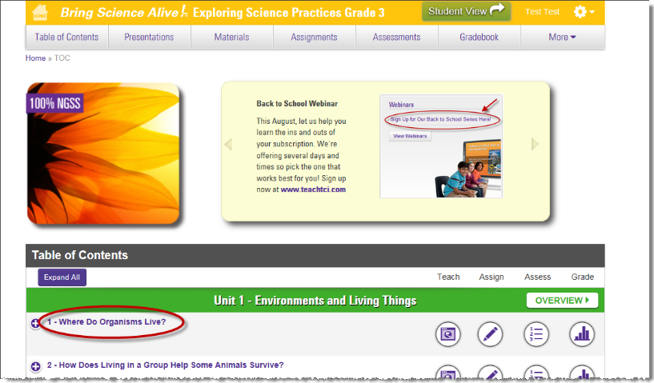
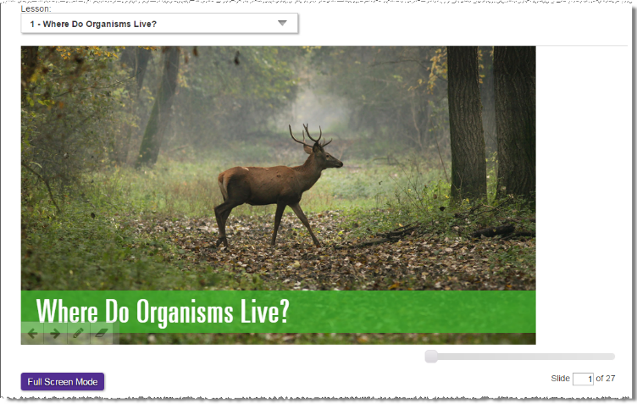

Step 4: The next time you visit, sign in from www.teachtci.com.

Just click the “Sign In” button in the upper right corner. Enter your username (email) and password.

