How to access your K-12 Social Studies.
  - To access your online literature or social studies series you must login to your Power Teacher account.
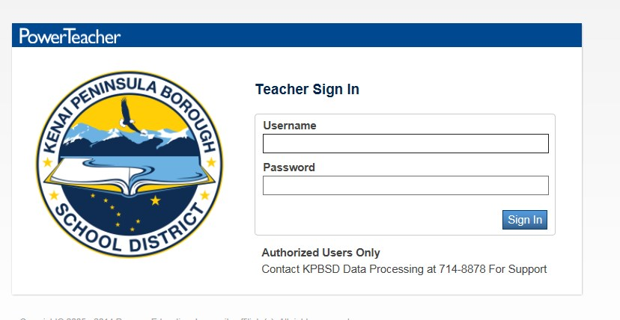
  - Once in your courses screen, in the upper right corner there is a square with an arrow coming out of it. Click on that, then click on “Pearson Courses” which is highlighted.
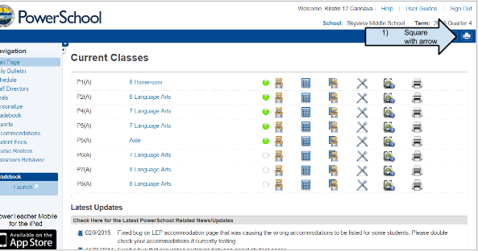

  - Managing products is how you add text and resources to the students Power School accounts. You have to add the products to each class. The “Manage Products” link will pop up with a drop down menu. Select the materials for either Literature or Social Studies materials. This will assign it to all of the students in the class.
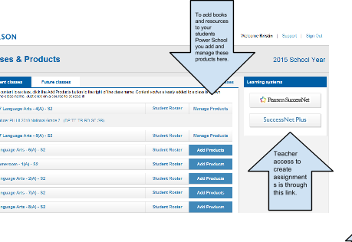
  - The social studies for K-8 begins with “My World _______”
  - For help assigning and managing any of the Pearson products (Literature, Biology, and Social Studies) go to: ​http://mypearsontraining.com/​ .

