6­12 secondary adopted materials math online for students and teachers:
  - Go to the website ​www.my.hrw.com​, register.

  - You MUST have a hard copy teacher edition for the course that you want to add to your account. It does not matter if more than one teacher is using the ISBN, but it does have to be with you because you will be looking up a word on a particular page to prove that you have a right to access materials.
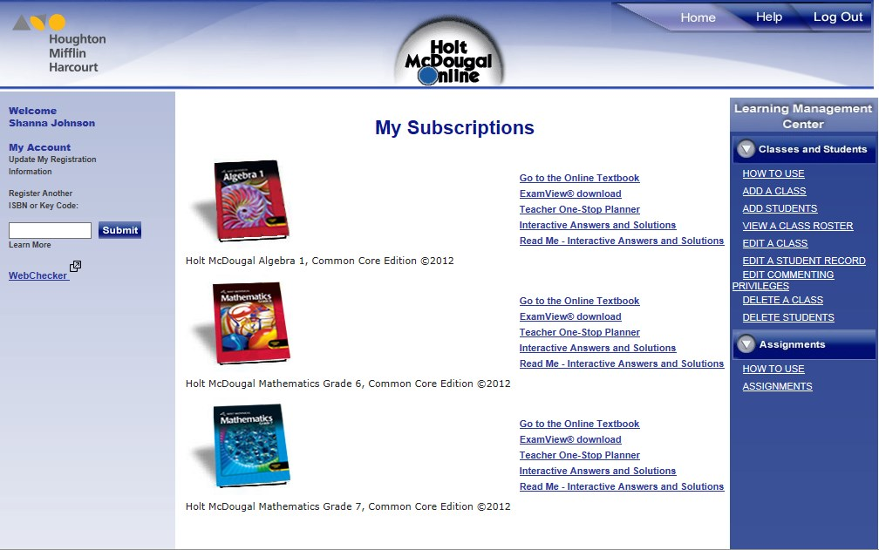
  - To link your math products to your Power School (or any item to your class in PS):
